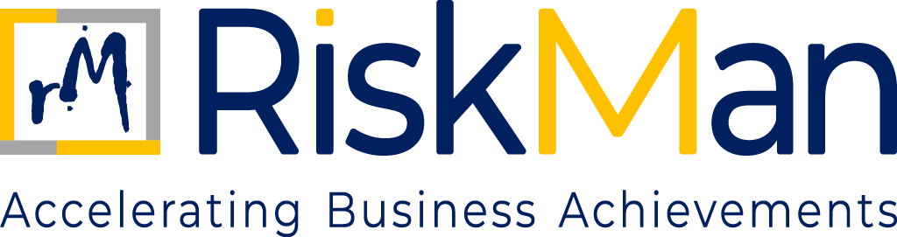
Code of Conduct
TABLE OF CONTENTS
Code of Conduct

- Objective…………………………………………………………………….……………………………………………………………3
- Scope………………………………………………………………………….……………………………………………………………3
- Policy………………………………………………………………………….……………………………………………………………3
- Prohibited Conduct…………………………………………………….……………………………………………………………4

CODE OF CONDUCT
- OBJECTIVE

The purpose of this Code of Conduct and Ethics is to promote conduct of business ethically in an efficient and transparent manner and to meet its obligations to all its stakeholders. The above guidelines and code of conduct are to be followed by each employee of RiskMan irrespective of his/ her hierarchy level and department. These guidelines, policies and code of conduct are designed to make sure that RiskMan and its employees carry out their responsibilities, ethically and honestly. All employees must follow these throughout their tenure at RiskMan.

RiskMan lays great emphasis on this code of ethics guidelines and believes that these are critical in ensuring a constructive and positive work environment at RiskMan along with portraying a good image of RiskMan to the outside world. Hence, RiskMan will not tolerate any violations and appropriate disciplinary action will be taken against any employee found to be violating these. RiskMan management will decide on the nature of such disciplinary action on a case to case to basis depending on the severity of the violation.

- SCOPE

This policy applies to all individuals and entities associated with RiskMan Consulting LLP. It covers all employees, including those who are permanent, contractual, or interns, as well as partners, consultants, and associates who are professionally engaged with the Firm. Additionally, the policy extends to clients, suppliers, vendors, and any other third-party stakeholders who interact with or are connected to the operations and business activities of RiskMan in any capacity.

- POLICY

- General Code of Conduct

It is the duty of each employee to:
- Respect the nature of privileged or confidential information regarding RiskMan, its officers, board, or staff;
- not use information obtained in the conduct of RiskMan’s business for personal or business advantage;
- Be certain that a position held with RiskMan is never used to obtain unauthorized, illegal or questionable benefit as it would apply to a partner, contractor, supplier or other party conducting business with RiskMan.

In addition, employees will not indulge in behaviour that can result in disciplinary action which includes, but is not limited to the following:
- Possible criminal action, verbal mistreatment of colleagues, an ongoing failure to follow supervisory instructions;
- tardiness or poor attendance;
- major violations of rules (possession of or the using of alcoholic beverages or controlled substances during working hours);
- inappropriate use of RiskMan’s property, equipment or facilities, fighting or violating safety rules including failure to report an accident involving RiskMan’s vehicles or equipment, insubordination, stealing, falsifying a time sheet or any official document, accepting a tip, gift, or bribe offered by a contractor or entity that may contract with RiskMan as a sign of appreciation for performance of required duties;
- committing other serious illegal acts.

- Outside Employment

No outside employment activity shall take place during normal work hours or using RiskMan’s premises, supplies, or equipment.

- Dress Code and Personal Appearance During Virtual Meeting

- Employees are expected to reflect a favourable image by appropriate dress and hygiene during for meetings/conferences/webinars.
- Moderation and common sense should be used in all these matters to assure the employee is suitable for work and the respective work environment.

- PROHIBITED CONDUCT

- Work Performance
- Insubordination, including disobedience, or failure or refusal to carry out assignments or instructions.
- Sleeping or engaging in unauthorized personal business.
- Unauthorized disclosure of confidential information or records.
- Falsifying records or giving false information to other state agencies or to employees responsible for record keeping.
- Failure to provide accurate and complete information whenever such information is required by an authorized person.
- Negligence in the performance of assigned duties.

- Attendance and Punctuality
- Failure to report promptly at the starting time of a shift or leaving before the scheduled quitting time of a shift without the specific approval of the supervisor.
- Unexcused or excessive absenteeism.
- Failure to notify the supervisor promptly of unanticipated absence or tardiness.

- Misconduct

The following are considered acts of misconduct and the employees will face disciplinary action if found indulging in any of the following:
- Wilful in subordination or disobedience, whether alone or in combination with others to any of the lawful and reasonable orders of the superiors.
- Theft, fraud, or misappropriation of company's funds dishonesty in connection with the employer's business or property.
- Wilful damage to or loss of RiskMan’s goods or property.
- Riotous or disorderly behaviour towards superiors, co-workers or any act subversive of discipline in connection with the work of RiskMan.
- Habitual negligence or neglect of work.
- Striking work singly or in combination with others or inciting others to strike work in contravention of the provisions of any law or rule having the forces of law/or any contract including the implied contract of appointment to attend and to work.
- Sleeping while on duty.
- Adopting, participation, instigating, encouraging abetting go slow tactics.
- Engaging in activities or giving false statements before any person or authority with the intention to cheat the company.
- Refusal to work overtime due to exigencies of work.
- Unauthorized disclosure, to any person, of any information regarding the process of the company, which may come in the possession of workman in the course of his work.
- Failure to observe safety instructions notified by the employer or interference with any safety device installed within the company.
- While in employment, working for any other employer for any consideration or otherwise.
- Entering the RiskMan premises without permission and / or authority outside the duty hours.
- Allowing an unauthorized person to operate his machine.
- Doing any act prejudicial to the interest of reputation of the company.
- Not taking proper care of the tools, gauges, jigs, fixtures, or any other company's property entrusted to him.

- Social Media Policy
- Employees need to know and adhere to the Company’s Code of Conduct, Employee Handbook, and other company policies when using social media in reference to RiskMan.
- Employees should be aware of the effect of their actions may have on their images, as well as Company’s image.
- The information that employees post or publish may be public information for a long-time employees should be aware that RiskMan may observe content and information made available by employees through social media.
- Employees should use their best judgment in posting material that is neither inappropriate nor harmful to RiskMan, its employees, or customers/ clients.
- Although not an exclusive list, some specific examples of prohibited social media conduct include posting commentary, content, or images that are defamatory, pornographic, proprietary, harassing, libelous, or that can create a hostile work environment.
- Employees are not to publish, post or release any information that is considered confidential or not public. If there are questions about what is considered confidential, employees should check with the Human Resources Department and/ or supervisor.
- Social media networks, blogs and other types of online content sometimes generate press and media attention or legal questions. Employees should refer these inquiries to authorized RiskMan spokespersons.
- Employees should get appropriate permission before you refer to or post images of current or former employees, members, vendors, or suppliers. Additionally, employees should get appropriate permission to use a third party's copyrights, copyrighted material, trademarks, service marks or other intellectual property.
- If employees publish content after‐hours that involves work or subjects associated with RiskMan, a disclaimer should be used, such as this: “The postings on this site are my own and may not represent Company’s positions, strategies or opinions.”
- It is highly recommended that employees keep RiskMan-related social media accounts separate from personal accounts, if practical.

- Sexual Harassment

Any employee by any means found to be involved in sexual harassment which involves employees or colleagues by any means will be considered as severe offense and therefore actions shall be initiated, and the perpetrator/s shall be liable including a severe punishment as per the policy of RiskMan and/ or in accordance with the applicable local Laws & Regulations.

Sexual harassment would mean and include any of the following:
- Unwelcome Sexual advances, request/demand/prayer/offer directly/impliedly/through a third party for sexual pleasure, favour.
- Unwelcome Sexual advances, request/demand/prayer/offer either unambiguously/explicitly or implicitly or by through any media or mode in lieu of or in return of money, promotion, employment, evaluation of a person towards any activity for which the Company directly and/or indirectly involved;
- Unwelcome sexual advances involving verbal, non-verbal, physical contact (such as sexually coloured remarks, jokes, letters, phone calls, e-mails, gestures, showing of pornography, lurid stares, physical contact, molestation, aggravation, display of pictures, signs, verbal or non -verbal communication (directly and/or indirectly) which offends any individual’s sensibilities and affect his/her performance;

